HOTEL MANAGEMENT SYSTEM

**A PROJECT REPORT**

*Submitted by*

Suraj Kumar Gupta

170301120024

*in partial fulfilment for the award of the degree*

*of*

BACHELOR OF TECHNOLOGY

*in*

Computer Science & Engineering



DEPARTMENT OF

**COMPUTER SCIENCE & ENGINEERING**

**SCHOOL OF ENGINEERING & TECHNOLOGY**

**JATNI, ODISHA -752050**

**NOVEMBER, 2019**

**DEPARMENT OF COMPUTER SCIENCE & ENGINEERING**

**SCHOOL OF ENGINEERING AND TECHNOLOGY**

**JATNI, ODISHA-752050**

**BONAFIDE CERTIFICATE**

Certified that This Project Report **“HOTEL MANAGEMENT SYSTEM**” is the Bonafide work of **“ Suraj Kumar Gupta”** who carried out the project work under my supervision. This is to further certify to the best of my knowledge that this project has not been carried out earlier in

this institute and the university**.**

**SIGNATURE**

**Ms. SWATI SUCHARITA BARIK**

**SUPERVISOR**

**Asst. Prof., Computer Science & Engineering**

*Certified that the above mentioned project has been duly carried out as per the norms of the college and statutes of the university*

**SIGNATURE**

**Dr. SUJATA CHAKRAVARTY**

**HEAD OF THE DEPARTMENT**

**ACKNOWLEDGEMENT**

I wish to express my profound and sincere gratitude to **Prof. Swati Sucharita Barik**, Department of Computer Science & Engineering, **CUTM** Bhubaneswar, who guided me into the intricacies of this project non-chalantly with matchless magnanimity.

I thank **Dr. Sujata Chakravaty**, Head of the Dept. of Computer Science & Engineering, CUTM Bhubaneswar and **Dr.Prasanta Mohanty DEAN, SOET CUTM** for extending their support during Course of this investigation.

I would be failing in my duty if I don’t acknowledge the co-operation rendered during various stages of image interpretation by supervisor.

I am highly grateful to supervisor who evinced keen interest and invaluable support in the progress and successful completion of my project work.

I am indebted to my guides for their constant encouragement, co-operation and help. Words of gratitude are not enough to describe the accommodation and fortitude which they have shown throughout my endeavour.

**SURAJ KUMAR GUPTA**

**TABLE OF CONTENTS**

1.0**.** Introduction 1

1.1. Purpose 1

1.2. Scope of Development project 2

2.0.Overall Description 3

2.1 Product Prospective 3

2.2 Product Function 3

2.3 User classes and Characteristics 4

2.4 Data Flow Diagram..……………………………………........................................4

3. System feature 5

4. Code Implementation and Database Connection and Outputs 6

5.0.Other Non-functional requirements 18

5.1 Performance Requirement 18

5.2 Safety Requirement 18

5.3 Security Requirement 19

5.4 Requirement Attributes 19

5.5 Business Rules 19

6 . Conclusion and Bibliography………………………………………………………....20

**1. INTRODUCTION**

* 1. ***Purpose***

This Project Hotel Management System is developed for hotels those are using a manual system to handle hotel processes. There are three main users in hotel management system, administrator, Manager and Receptionist. Administrator can maintain daily updates in the hotel records. This system will automate the major operations of the hotel. Administrator can access to all system functionalities without any restrictions. Administrator is must be an authorized user. He can further change the password. There is the facility for password recovery, logout etc. Manager can access to all system functionalities with limited restrictions. Receptionist can only access to the Reservation Management section. The main aim of the entire activity is to automate the process of day to day activites of hotel.The Reservation System is to keep track in room and hall reservation and check availability. Using this system user can check which room is reserved and which room is available. He can reserve room from reservation module. The Room Management System is for manage all room types room services. Room management module help user to keep track of all information of hotel room. He can check room laundry service, food service and sweeping service from this module. The Inventory Control System will keep track in all inventories of the hotel and guest details will handled by guest management. Administration department will monitor the all. the main of developing this system is to computerize all the activity of the hotel like Admission of a New Customer, Assign a room according to customer’s demand, checkout of a customer and releasing the room and finally compute the bill etc. Using this system you can manage check in and check out process easily.

The main objective of the entire activity is to automate the process of day to day activities of Hotel. Using this system you can manage room activities and keep track of admission of a New Customer. Using this system you can check rooms according to customer’s need and can assign easily room to customer. Checkout of a customer and updating the releasing room information in the system is very easy. When user do checkout system will generate final bill after calculating all the bills. User can also check online, all the packages available. He can also book rooms online. He can also cancel booked room online. Hotel management can also check the list of Regular customers and feedback of the hotel’s customer.

***1.2 Scope Of Development Project***

The scope of hotel management ranges from housekeeping and general cleaning to providing customer service. A manager is responsible for everything that happens in the hotel, so the scope for the job generally covers everything that goes on in the hotel. The hotel management system is in charge of all of the management for a hotel. It will including everything from linens on the bed to the chef at the hotel.

**2.IDENTIFICATION OF THE PROBLEM**

***2.1 Product Prospective***

The Hotel Management System is new self-contained software product which will be produced by the project team in order to overcome the problems that have occurred due to the current manual system .The newly introduced system will provide an easy access to the system and will contain user friendly functions with attractive interfaces . The system will give better options for the problem of handling large scale of physical file system, for the errors occurring in calculations and all the other required tasks that has been specified by the client. The final outcome of this project will increase the efficiency of almost all the tasks done at all the Hotel in much convenient manner.

***2.2 Product Function***

* Make Reservations
* Search Room
* Add Payment
* Issue Bills
* Manage Guest(Add, Update Guest)
* Manage Room Details(Add, Update, Delete)
* Manage Staff (Add, Update, Delete, View)
* Manage Inventory (Add, Edit, Delete)
* Set Rates
* Retrieve Reports(Staff payment, Income)
* Manage Users(Add, Update, Delete)
* Taking Backups

***2.3 User Classes and Characteristics***

Owner:-

Owner of the Hotel can monitor and authorize the task handle by the system. Owner can use all the functions performed by the system. Owner of company as well as the system can access to the administrator panel which is consider the core of the system. As the owner of the company gets the ability to manage the other users including their user levels and privileges.

Manager:-

Manager is responsible for managing resources available in hotel management system.Manager also has most of the privileges mentioned above except the things regarding the payment handling .The reason for using a Manager is to reduce the work load done by the owner that cannot be assigned to receptionist ,as those tasks seem much responsible.

Receptionist:-

As a hotel receptionist ,he or her role will be to attain the goals of bookings and to ensure that all guests are treated with high standard of customer service .Hierarchically receptionist role has the least accessibility to the system functions**.**

***2*.*4 Data Flow Diagram***

**LEVEL-0C:\Users\USER\Pictures\Screenshots\Screenshot (79).png**

**LEVEL-1** 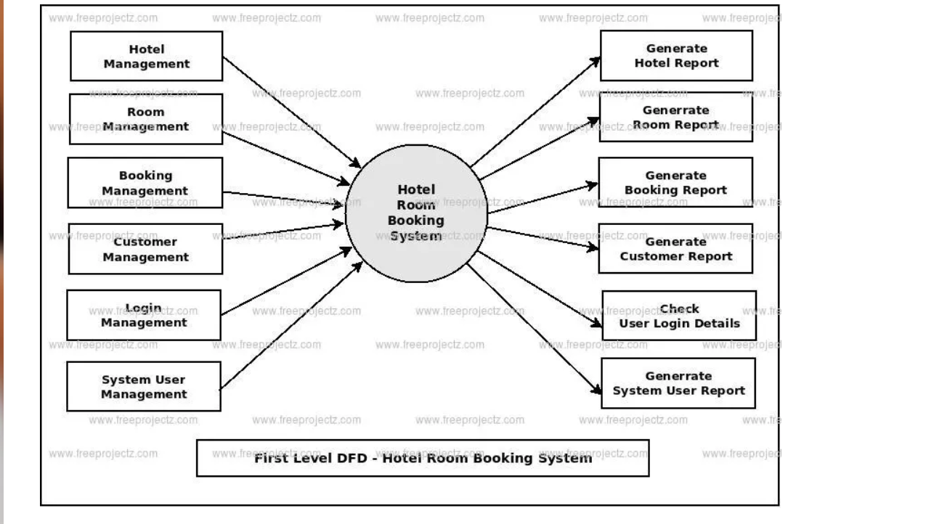

**LEVEL-2**

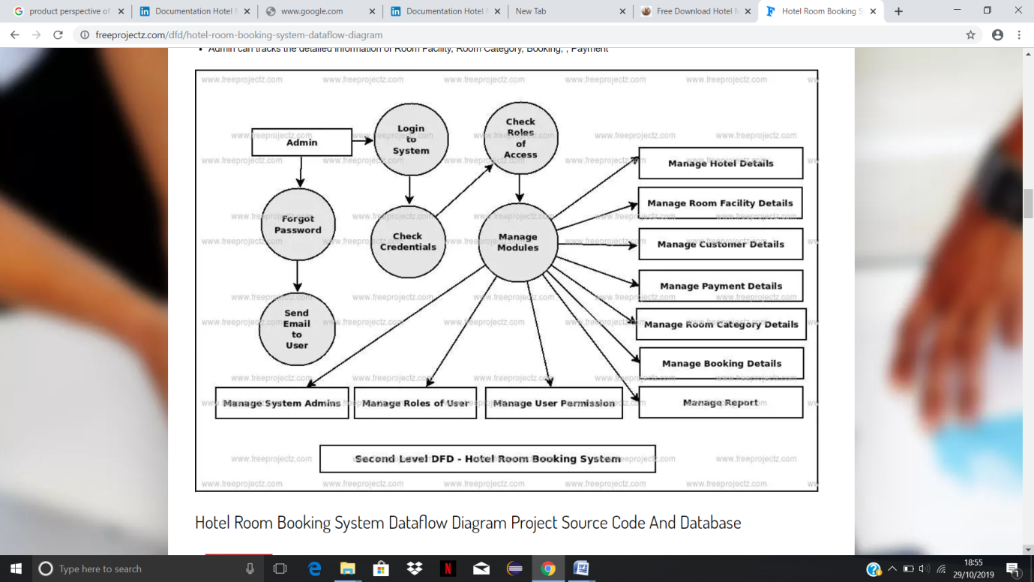

**3. System Feature**

* Cloud-based hotel software saves time spent on manual updates
* No investment required for IT maintenance and support
* Access to a single dashboard to control all functions
* Easy connection with Online Travel Agencies (OTAs) to manage room rates, availability, etc.
* Allows integration with channel managers
* Professional support at all hours
* Smart and seamless experience for all
* Pay-as-you-go service, upgrade easily, quick installation
* Generate various types of reports with a few clicks

**4.CODE IMPLEMENTATIION AND DATABASE CONNECTION**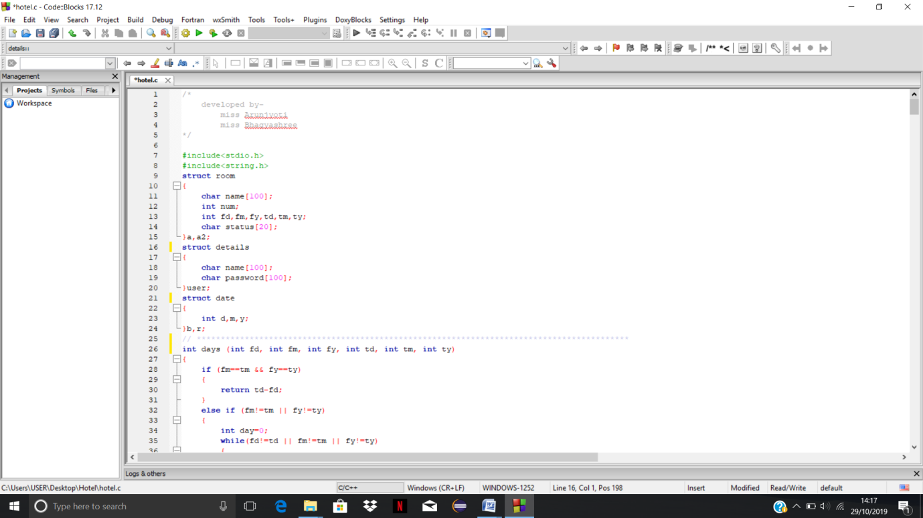

**C:\Users\USER\Pictures\Screenshots\hotel screenshot\Screenshot (59).pngC:\Users\USER\Pictures\Screenshots\hotel screenshot\Screenshot (60).png**

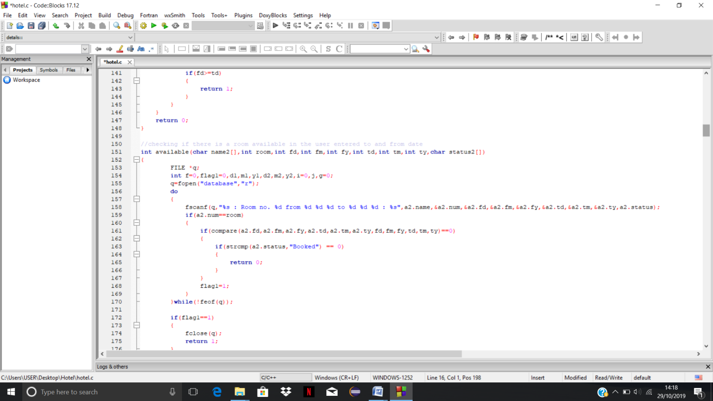

**C:\Users\USER\Pictures\Screenshots\hotel screenshot\Screenshot (62).png**

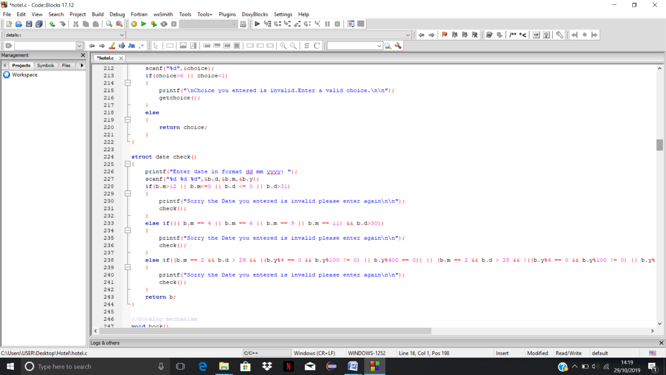

**C:\Users\USER\Pictures\Screenshots\hotel screenshot\Screenshot (64).png**

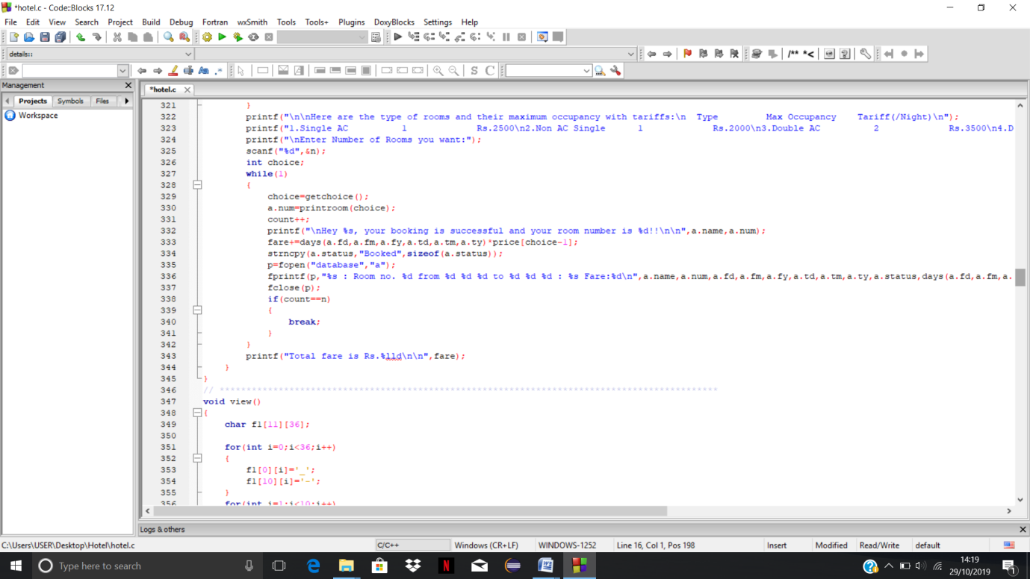

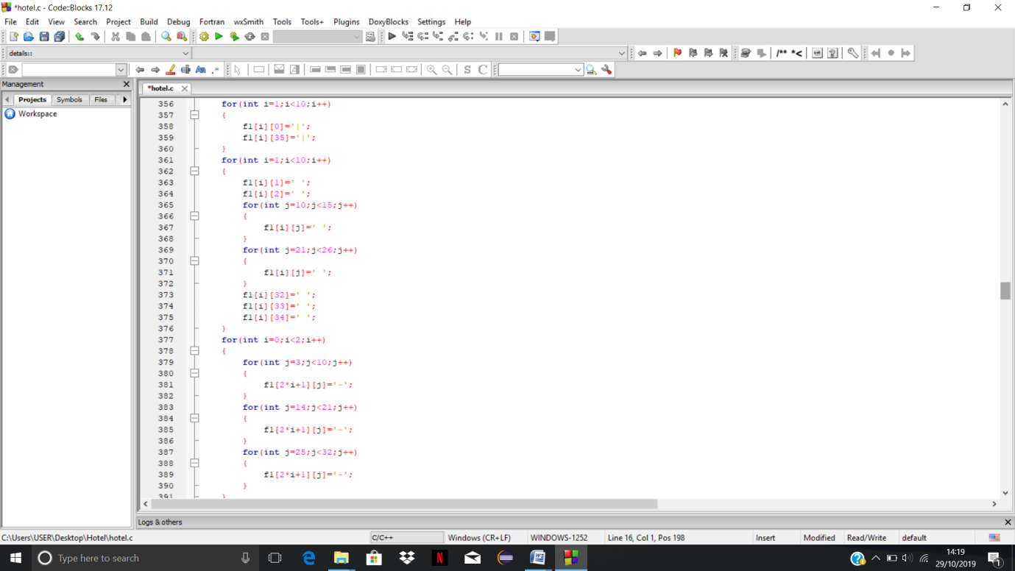

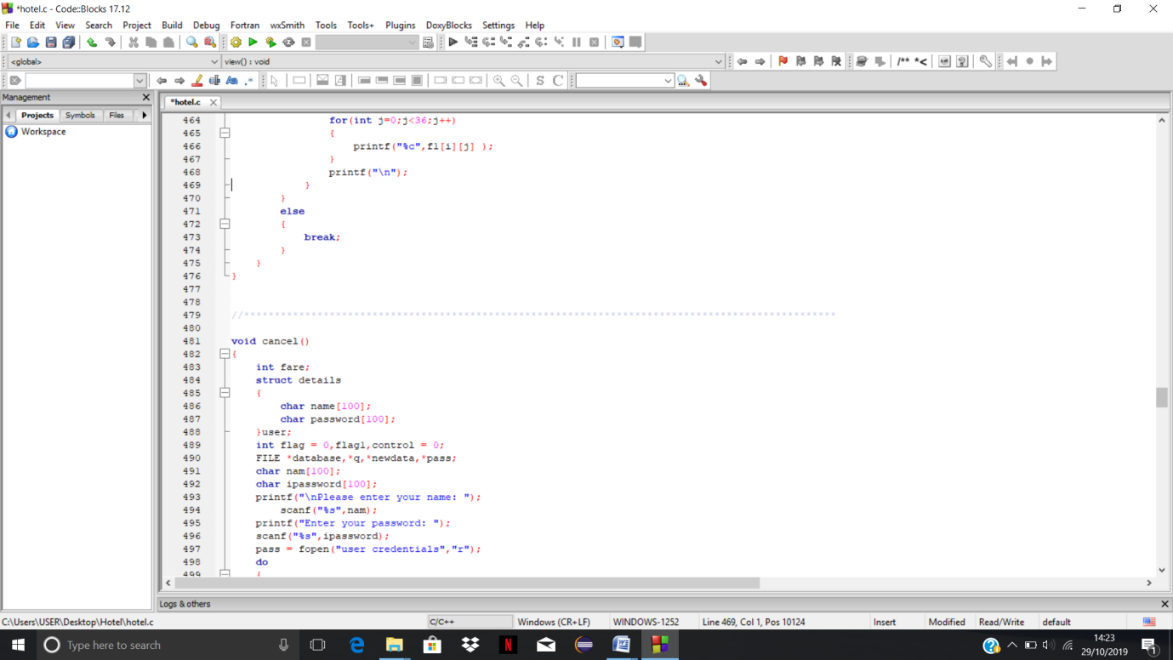

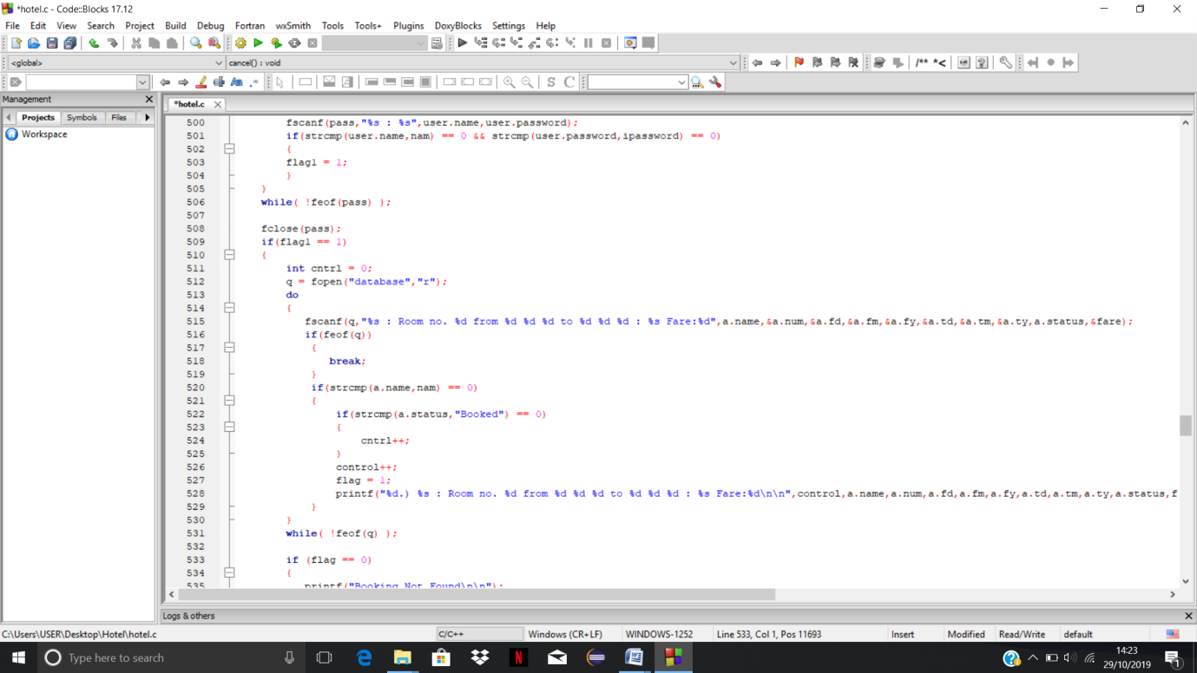

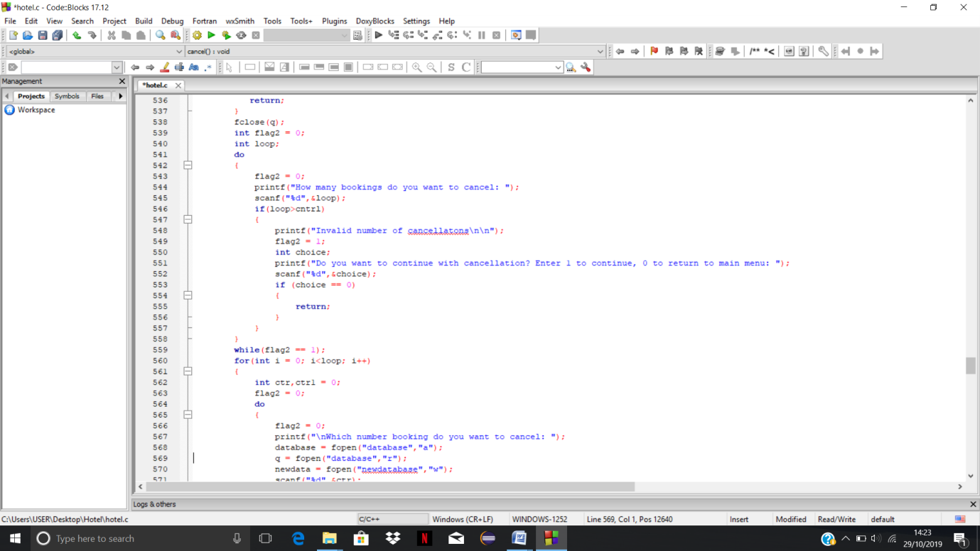

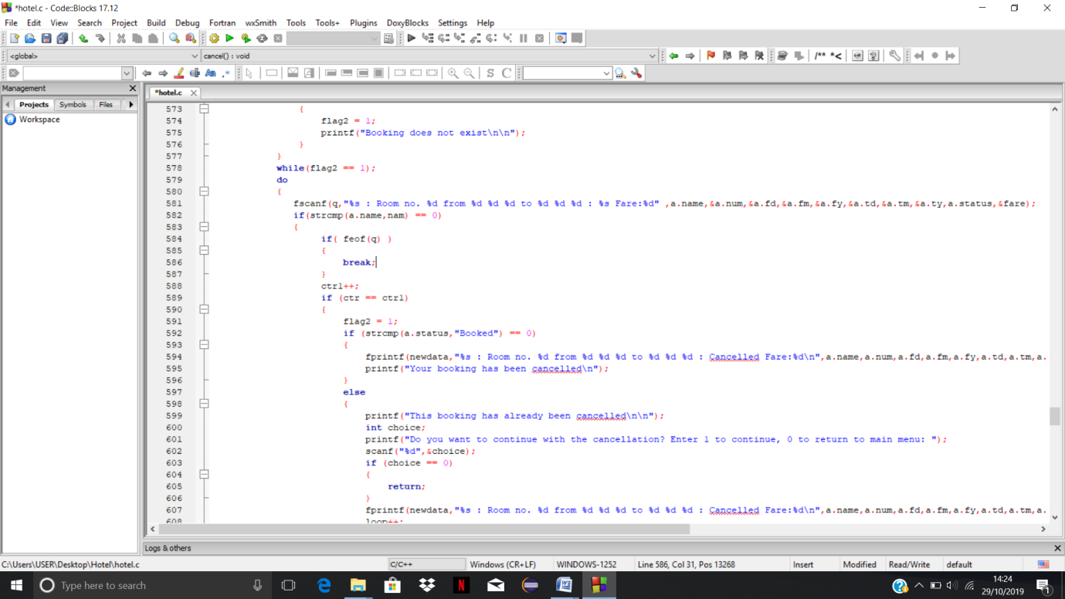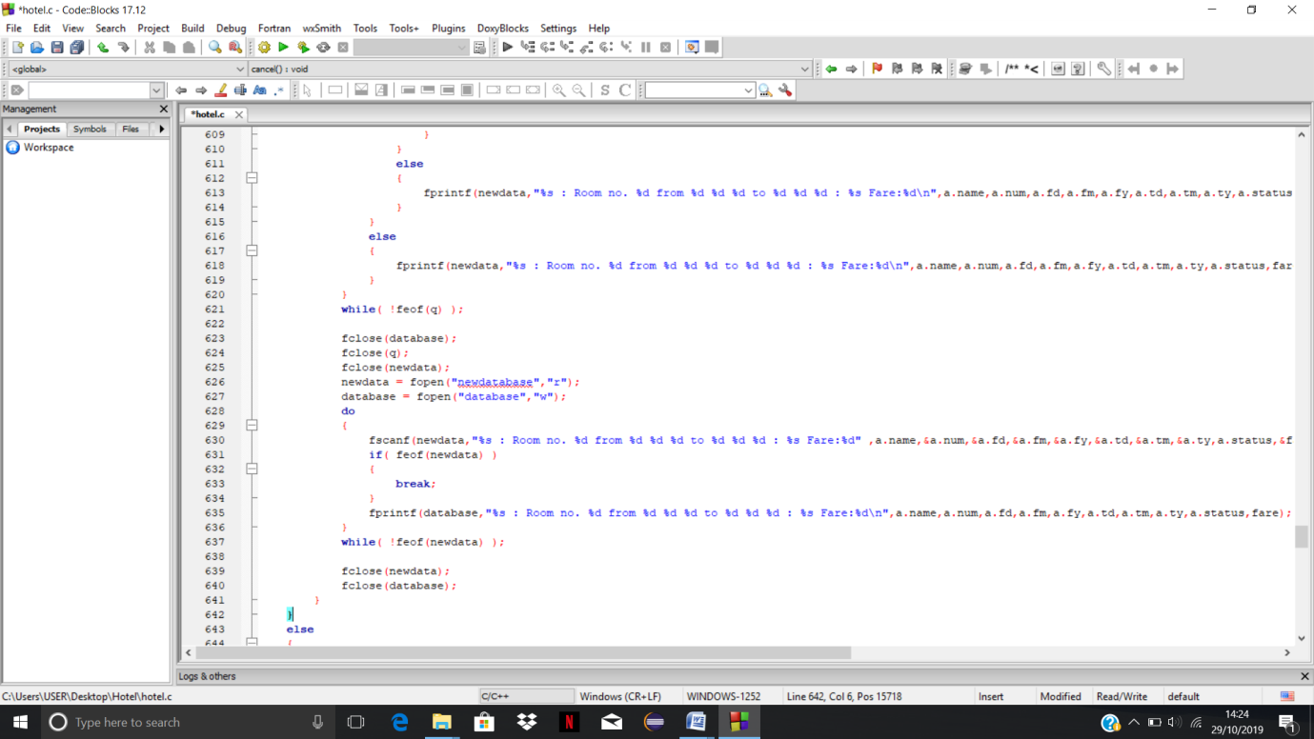

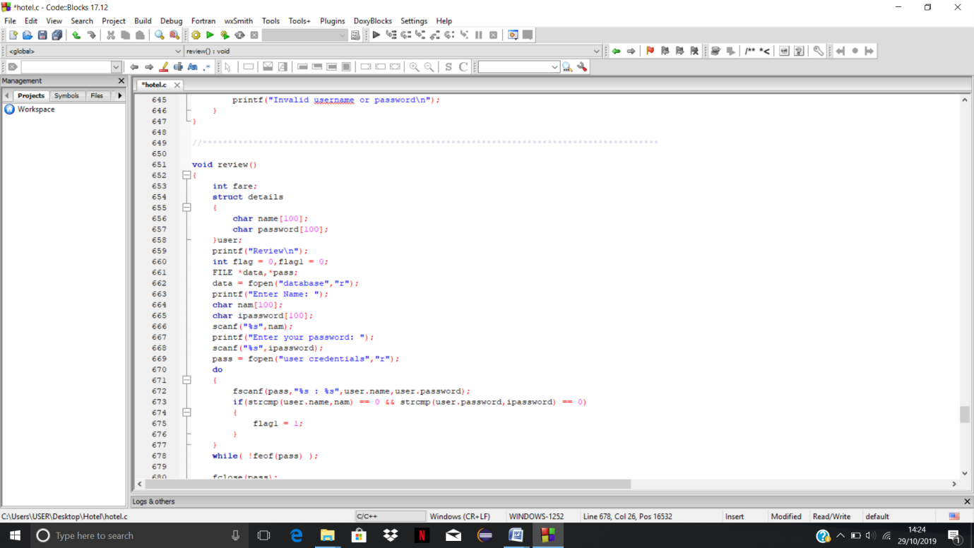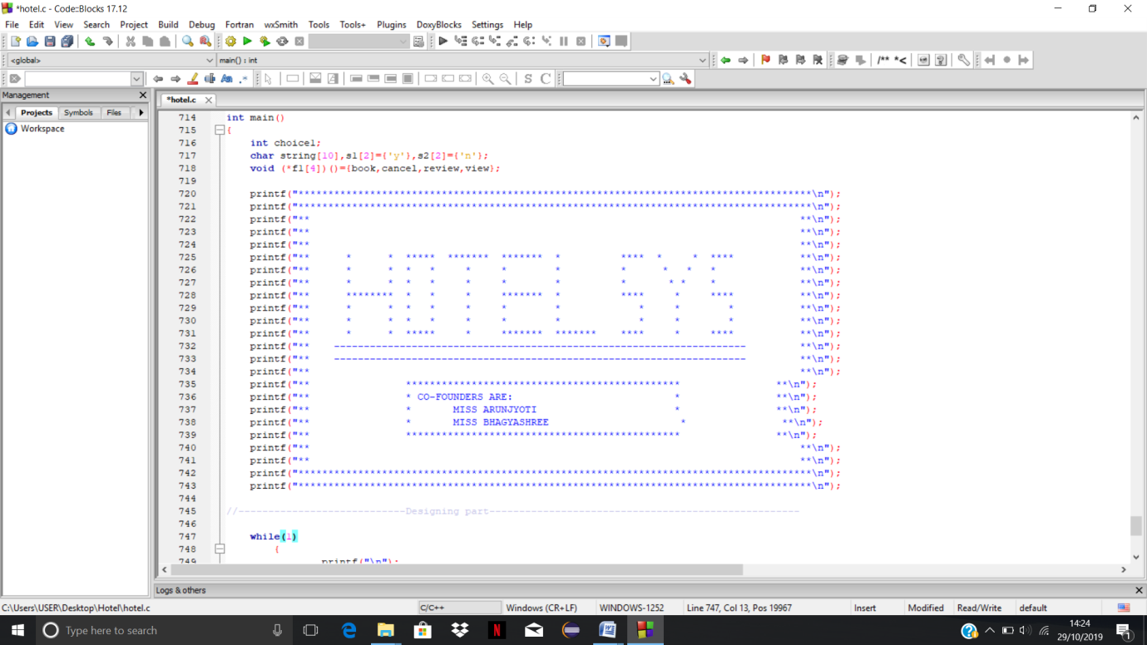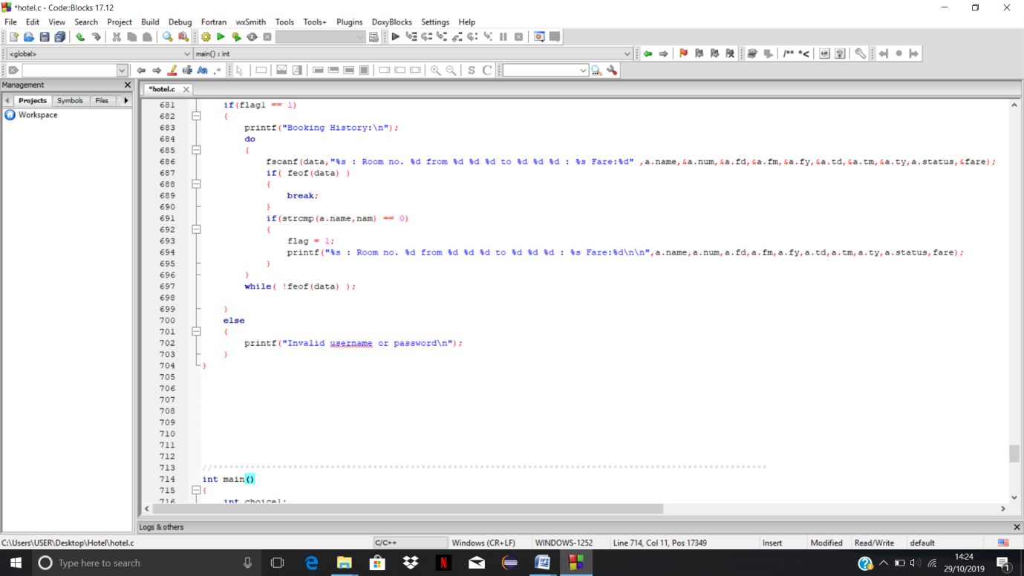

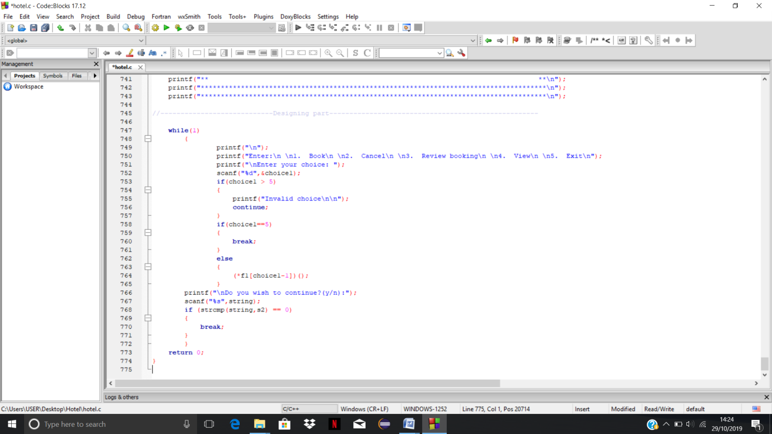



**OUTPUTS**

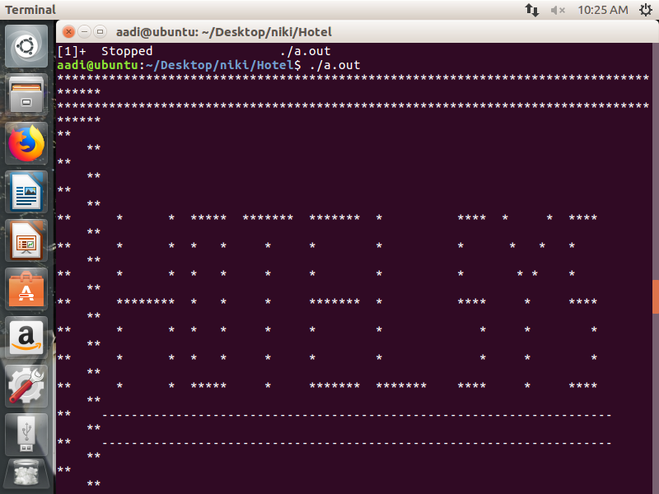

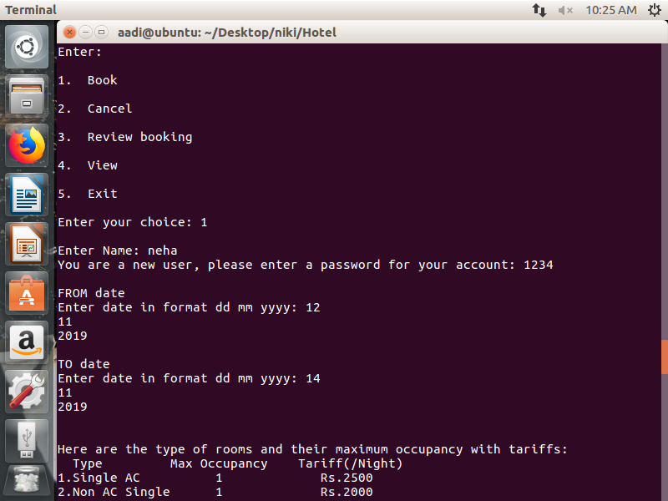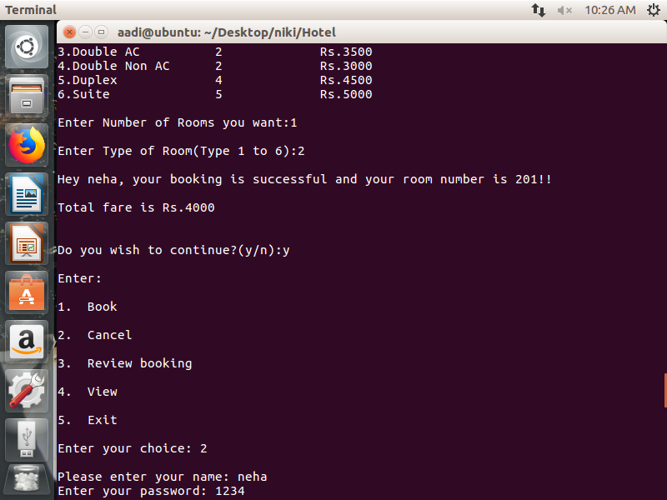

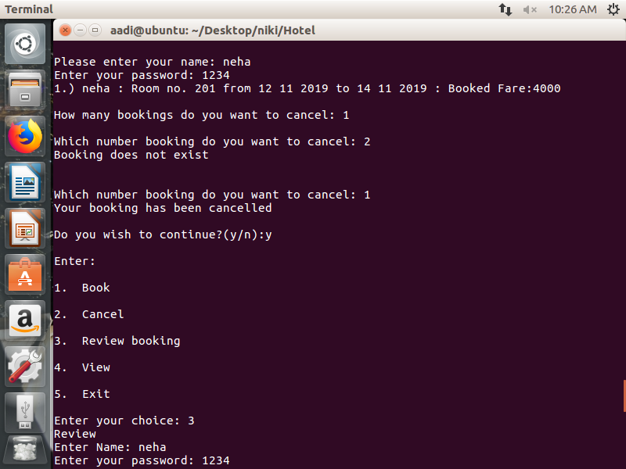

**5. OTHER NON-FUNCTIONAL REQUIREMENTS**

***5.1 Performance Requirement***

Perfomance requirements define acceptable response times for system functionality.

* The load time for user interface screens shall take no longer than two seconds.
* The log in information shall be verified within five seconds.
* Queries shall return results within five seconds.

***5.2 Safety Requirement***

There are several user levels in hotel management system, Access to the various subsystems will be protected by a user log in screen that requires a username and password. This gives different views and accessible functions of user levels through the system. Maintaining backups ensure the system database security. System can be restoring in any case of emergency.

***5.3 Security Requirement***

Customer Service Representatives and Managers and owner will be able to log in to the Hotel Management System. Customer Service Representatives will have access to the Reservation/Booking and subsystems. Managers will have access to the Management subsystem as well as the Reservation/Booking subsystems.

***5.4 Other Requirement***

When the system is completely developed and submitted to the client ,few sessions will be required to make the users of the system understand about the functionality of it and some time to adapt to the system.

**6.CONCLUSION**

This project is designed to meet the requirements of Online Hotel Management System. It has been developed in Visual Basic keeping in mind the specifications of the system, For designing the system we have used simple data flow diagrams.

Overall the project teaches us the essential skills like:

    · Using system analysis and design techniques like data flow diagram in designing the system.

  · Understanding the database handling and query processing.

**7. BIBLIOGRAPHY**

* http://www.slideshare.net/
* http://www.w3school.com/
* www.Google.com